**Logging using SLF4J Exercise 1: Logging Error Messages and Warning Levels:**

**Added dependencies in pom.xml**

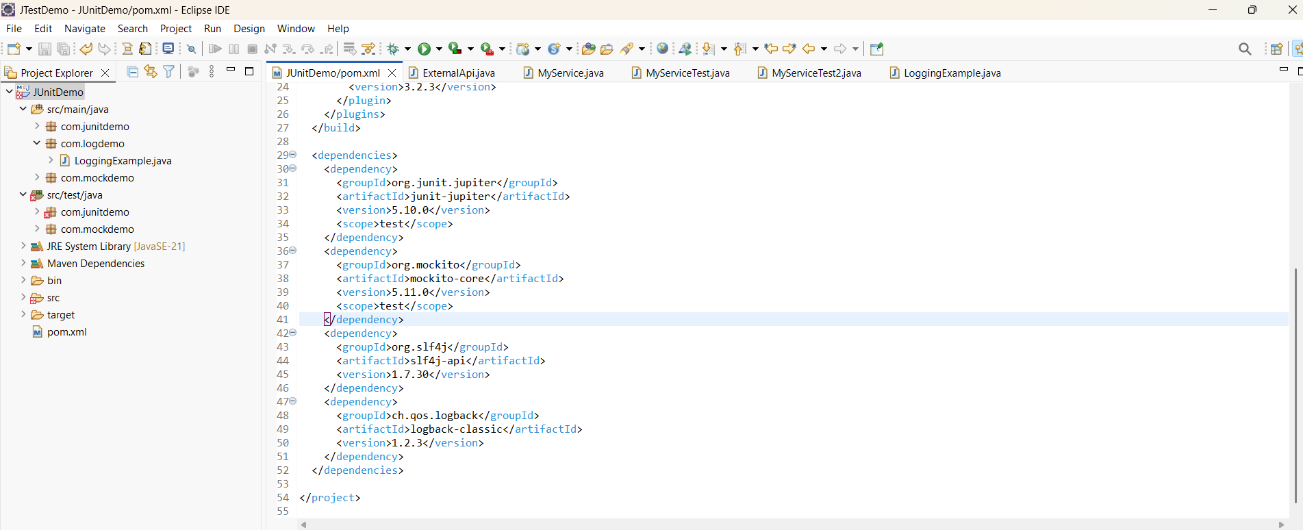

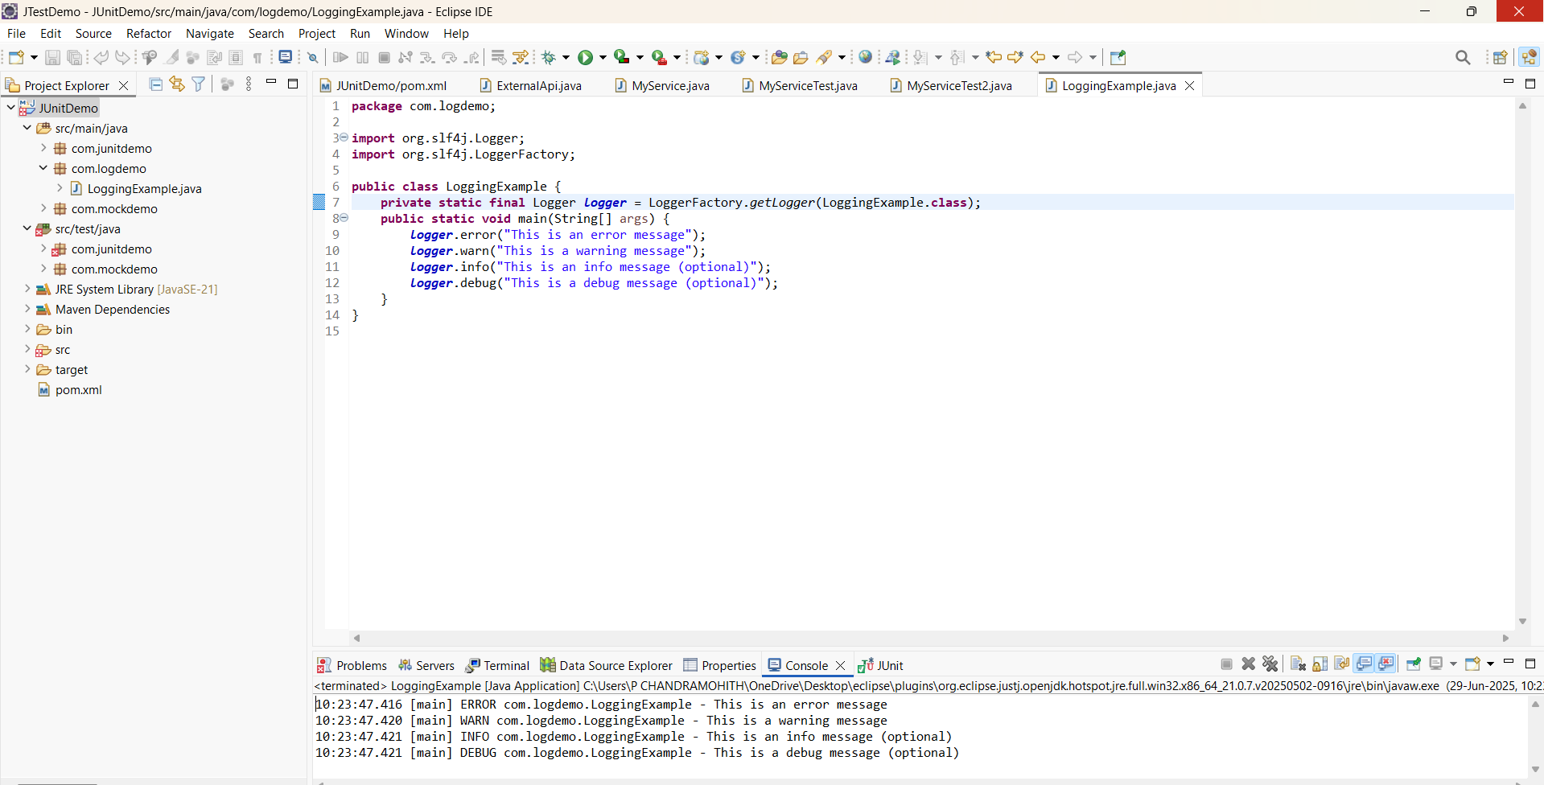

**Output:**

